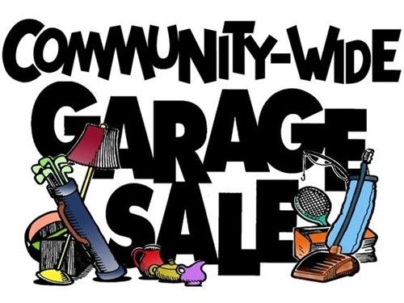

It’s time for the
Banbury Meadows Fall 2018
Garage/Yard Sale
When: Saturday September 29 from 8 AM to 6 PM
Clean out those closets and garages and get ready to make some cash! Or, you can shop for bargains walking distance from home. Or, just use this as a time to chat with all your neighbors who will be out and about.
Homeowners are reminded not to display items on sidewalks or along street curbs.
If you have any questions or need more information in this regard, please contact Brenda Hines, our Association Manager at DSI, Tel # 208-939-6000 or email at brenda@dev-services.com.

